

The Blur Cure
Updated: Oct 17

Welcome to a journal entry about a poem I wrote, featuring an intro longer than a Monday morning before your first cup of coffee or tea. Well, go grab something to drink, settle in, and prepare for a read that stretches out further than the line at an ABM on pay day—don’t worry, there’s light and laughter at the end of this wordy tunnel! I woke up on the wrong side of the bed this morning—though, let’s be honest, every side of the bed feels wrong when an alarm clock is involved. I dream of a job letting me sleep in until noon. Teaching Chinese students requires opening my eyes before the sunrise which should be illegal... Even 7 am would feel like winning the lottery—provided the lottery is paid out in sleep and not, you know, actual money. After surviving a class that felt more like a speed-dating session with learning, I thought, “Well, what better time to write a blog post about patience and time?” The irony wasn’t lost on me—here I was, wrestling with my own impatience, courtesy of a student whose patience had the lifespan of a popsicle in July. Is patience contagious, or is it more like the last slice of cake at a family dinner—everyone claims to have it, but it mysteriously disappears when you need it most?

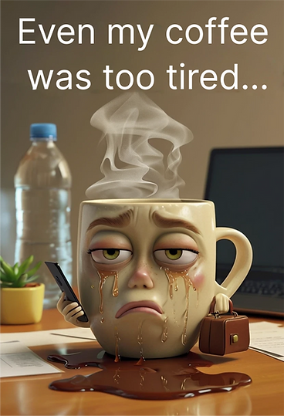
Inspired by a Pinterest pic discovery, adapted and generated by me and A.i.

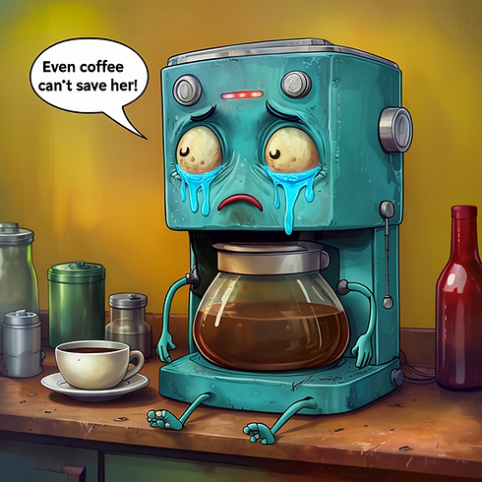
Same as above...

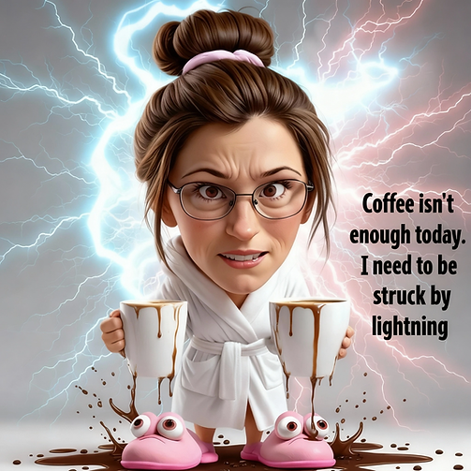
My attempt at turning myself into a bobble head.
I'm learning how to make "characters"... I am quite a character!

Want to hear what happened? There I was, poised to dazzle my student with an engaging, educational video—complete with an animated reward I’d spent a small fortune on and enough hours arguing with Art A.I. to qualify for diplomatic immunity. But suddenly, Mom swooped in like a SWAT team and snatched the screen as if she was negotiating a hostage release. “Sorry. My son isn’t happy. He wants to end class now.” I glanced at the clock: ten minutes in. My only weapon in this virtual standoff? A polite: “I’d be happy to continue teaching…” Meanwhile, my brain was running stats on whether this was a new world record for quitting class. After nearly a decade of virtual teaching and over five thousand lessons, you’d think I’d experienced it all. Yet there I was, staring at my webcam, mouth agape, wondering if this kid had a secret remote eject button. Kids almost never bail early during a trial lesson—usually, you at least get to the part where you teach them to say, “I don’t know.” But today’s session? It was less a lesson and more a drive-thru: pull up, take a quick look, and speed off before I even get to sell popcorn. Of course, trial lessons are often free, or at best, generously discounted—so you’d think folks could handle a whole fifteen minutes to figure out if online learning is their jam. But in the age of TikTok, if your content lasts longer than thirty seconds, it might as well be written in hieroglyphics. Welcome to the fast-forward generation: if it’s not on triple-speed (I blame Gilmore Girls, in part, for this trend! Talk fast, no faster…), it’s basically in slow motion. I’m half expecting requests for “Instant Noodle Soup Lessons”—served up in GIFs, memes, or, heck, just beamed straight into students’ brains via Wi-Fi. That’s a Black Mirror episode waiting to happen. The thought of me lurking inside my students’ heads? Talk about nightmare fuel! Besides, homemade soup takes time, and everyone knows it’s way tastier than the instant stuff. By the way, my soup obsession is still simmering nicely. Extra sourdough bread, please – without the calories?!

While I did manage to wrangle my way through the entire lesson—like a true Canadian, apologizing my way to the finish line—my inner job-hunter started whispering in my ear, “Hey, how about finding a gig where you don’t need a caffeine IV just to stay awake before sunrise?” Suddenly, I was reminiscing about the last time a job stressed me out this much; I think I almost invented a new Olympic sport: competitive sighing. Fun fact: I even wrote a poem about it called “The Blur Cure”—because nothing says catharsis quite like rhyming your confusion. So, let’s jump farther into today’s post: a little tribute to precious time, patience, and why we’re always in such a rush to do absolutely everything, yet somehow end up spending too much time doing nothing, or accomplishing things that, in the grand scheme of things, matter about as much as a snowman in July.

Due to Covid’s effect on China, I took a brief hiatus from virtual teaching and tried some other jobs. Now, I’d love to tell you I spent that time training squirrels to deliver coffee directly to your bedside, but instead, I completed a two-week training program with a tech company. It was, without exaggeration, one of the most stressful experiences of my life—think Olympic-level anxiety meets Canadian politeness. To this day, I still wonder how a job that involved answering phones made me as frazzled as cramming for finals at McGill University (if you ever want to experience existential dread, try troubleshooting a computer over the phone while a supervisor watches your every move like you’re about to commit a federal crime). It was, supposedly, just a customer service job. Spoiler: my naiveté about customer service was like a snowman in July—melting fast under the heat of reality. People don’t just have high standards; they have the patience of a squirrel on an espresso bender. I’ll never forget one guy in training who relished his role as ‘impatient customer’ a little too much, barking, “What’s taking so long? How slow can you be? Didn’t graduate from high school, did you? I don’t have all day. Hurry up…” He was auditioning for ‘Meanest Guy at The ABM’ and frankly, he nailed it. Yet, that wasn’t even the hardest part. My main trainer disappeared halfway through—and was swapped out for someone who thought lunch breaks were a myth. Who eats lunch at 4 pm, anyway? That’s not a break; that’s a hostage negotiation with your stomach. Due to “security” protocol, I had to keep my door shut during a record-breaking heat wave. There I was, sweating so much I started to worry I’d become a snowman in July, a puddle of mush. Dizzy, migraine-y, and half-blind (my glasses were so outdated, I’d have missed spotting Bigfoot if he showed up with a resume). If you’ve read my other blog posts, you know there was more going on health-wise, but let’s not turn this into a medical drama.

But hands down, the most challenging part of that training experience was the epic saga known as “Password Hell.” I swear, I created a gazillion passwords a day—my brain was running out of pet names (and over the years, I’ve cared for over 12 pets!), favourite TV shows, and secret crushes. Honestly, why did every single icon on that screen need its own set of twenty passwords? I felt like I was auditioning for ‘Canada’s Next Top-Secret Agent,’ except the only thing I was protecting was my ability to remember which version of which password I’d just used. Was the password screaming in ALL CAPS, or just whispering with a rogue capital here and there? Did I tack on this year, last year, or that special year only I remember? Who was I kidding? I don't remember that special year because they were all special to me for one reason or another. Which one of my “lucky” numbers did I throw in—my birthday, the number of migraines I had the day I created that password (during training, that number was extra high!) or the number of days I didn’t have a migraine that month? Did I end with a single exclamation mark for subtle flair, or did I go full drama with more exclamation marks than a teenager texting about their favourite K-pop band? Now that I’ve watched K-Pop Demon Hunters, I’m starting to understand the craze. By lunch, my memory was so fried, I considered writing passwords on my arm—except then I’d need a password just to read my own skin. If cyber-security ever called me for a job, I’d demand extra pay for PTSD: Password Trauma Stress Disorder! To top it off, my final exam got postponed five times, and my foot fell asleep so long I started Googling “do feet have hibernation cycles?”—all thanks to a spinal stenosis flare. I finally quit and landed a gig where lunch breaks are an actual thing, and the odds of me melting into a tragic puddle of sad ice-cream are dramatically lower—unless, of course, someone moves the thermostat to “Arctic” or announces a surprise karaoke showdown at noon. At least now, the only thing I risk missing is my soup spoon, not my sanity.

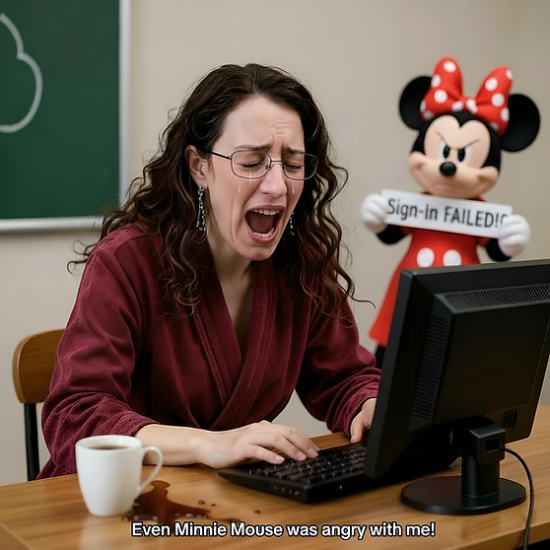
NOTE: 📌💡This is an A.I. generated image of me. It's not actually me.
Just A LOT of editing, A LOT! Too much...

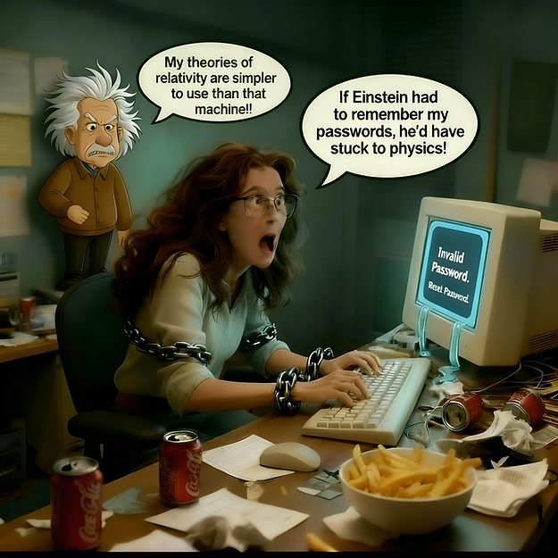

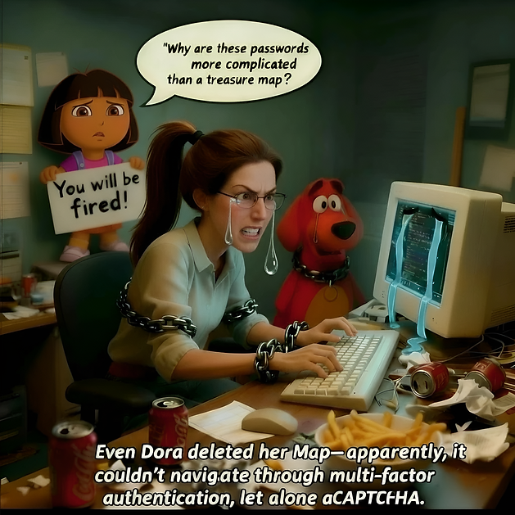
Another artificial image of me... although more obvious than the first one. The first one kinda scares me! 😳🙃🤣

And that’s exactly what sparked my poem, “The Blur Cure.” Truth be told, I’m not built for the go-go-go lifestyle—I’m more “slow-mo” than “FOMO.” If we rush too much, we end up missing the good bits. Don’t forget to take a look at the attached graphics for extra giggles. Until next time, take a moment to savour whatever’s in front of you—be it flowers, coffee, tea, or even your neighbour’s questionable lawn gnome. Post below and share your current view; extra points if it includes soup, sourdough, or a mug that’s as big as your patience. Remember: life isn’t a race, unless you’re sprinting toward the last slice of pie. Life Lesson #3: Slow down, soak it in, and enjoy every blurry, beautiful moment while you can!

PS - Here's my poem... (🚩 Note: A.I. was NOT used to write this poem. It's 100% W.H.Y.)

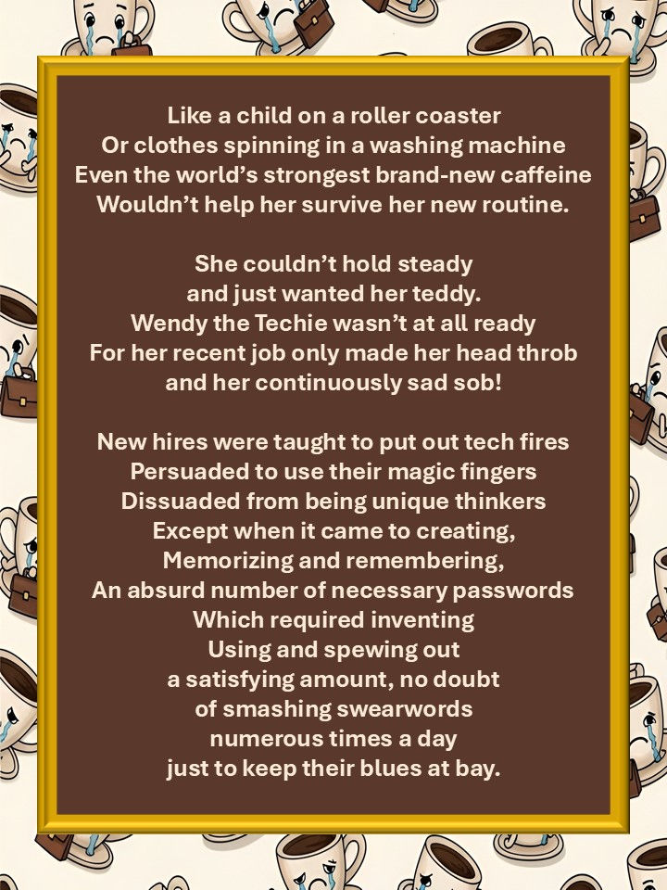
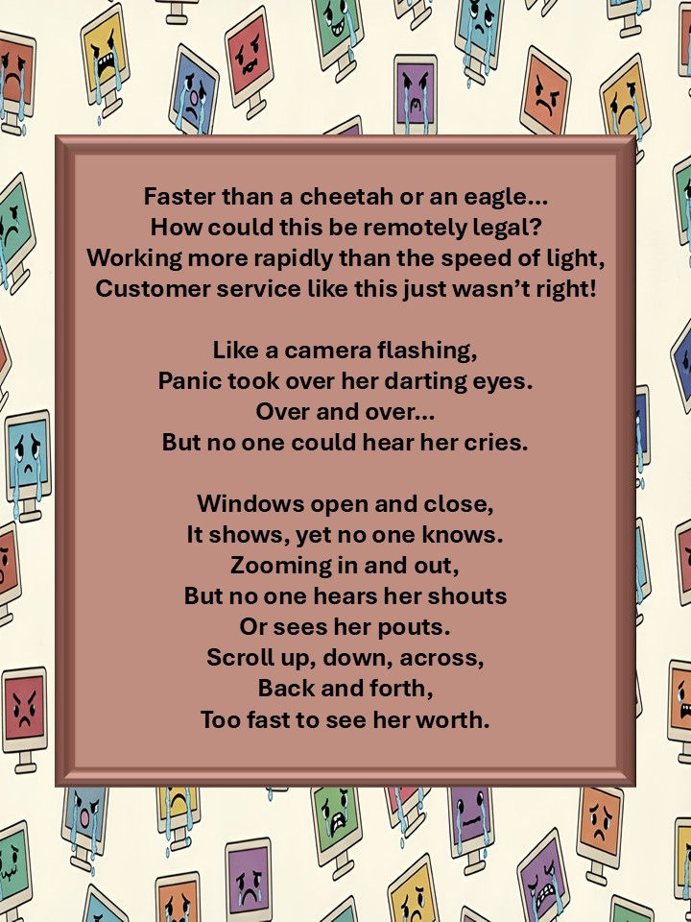
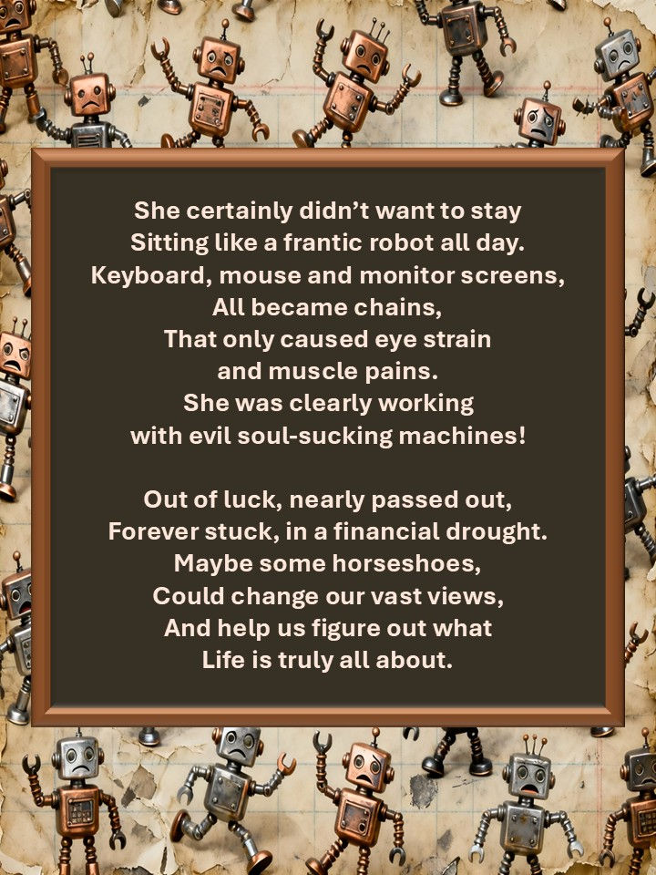


BONUS PICS:

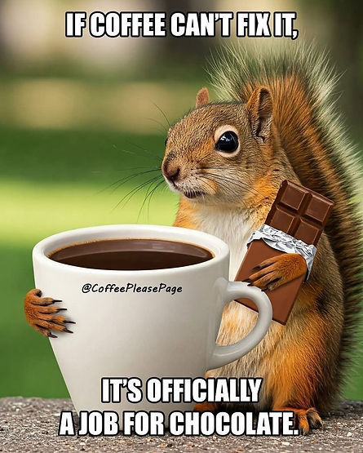
I was so tired, I forgot chocolate was an option!
NOTE: This pic was not "generated" by me, merely a Pinterest find.
Copyright: @CoffeePleasePage

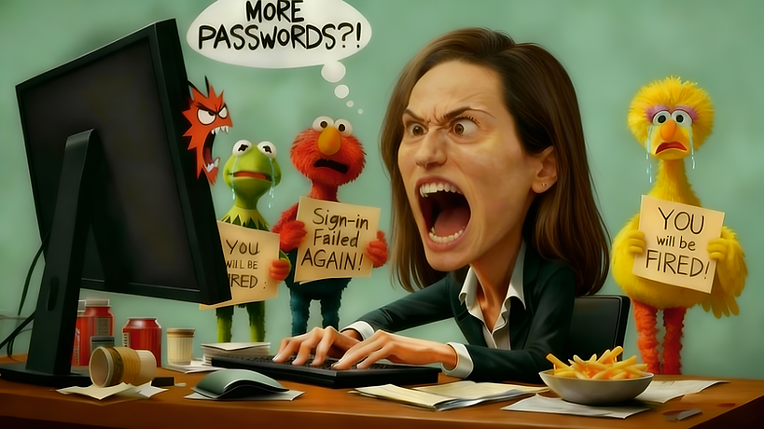

During my training I started to sing kids songs in my head so that was the inspo for the image above. I've never wanted to sing kids songs more. You know you've really "crashed out" when you start imagining talking Sesame Street characters... This bobble head version of me also creeps me out, but I feel worse, sad even looking at Big Bird and Kermit. And that red angry face in front of the monitor screen - that was a happy a.i. accident.

